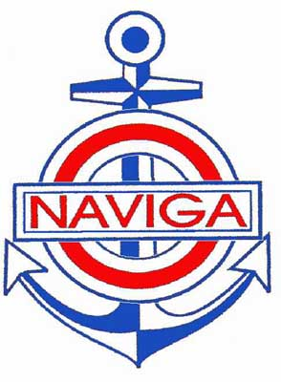

NATIONAL CHAMPIONSHIP OF SHIPMODELS SECTION “C”
BULGARIA – OPEN
JUNE 18 – 21, 2015
SUNNY BEACH - BULGARIA

ORGANISERS: | Bulgarian Federation of ship model sport  Model club Nesebar and Model club Stara Zagora  Sunny Beach AD – BULGARIA
LOCATION: | Conference room Sunny Beach AD
TIME: | JUNE 18 – 21, 2015
Main judge: | Eng. Evgeni GENOV
Representative of organizing Committee : | Eng. Evgeni GENOV - President of the Bulgarian federation of ship model sport.
PARTICIPATION: | - Valid membership of NAVIGA  - Correctly completed registration form  - Technical certificate and technical documentation of model;  - Fees paid
COMPETITION CLASSES: | New “Bonev” rules (experimental)  C-1, C-2, C-3,C-4 (A,B,C), C-5
REGISTRATION: | Conference room Sunny Beach AD  JUNE 18, 2015 from 10.00 to 18.00
ENTRY FEES: | EUR 15 - Senior  EUR 10 - Junior
EVALUATION OF MODELS: | NAVIGA rules and experimental “Bonev” classes
BANQUET: | EUR 20
Address of the organizer for sending the applications: | Business center “LINK”- Kvalitet sport store  168A, “Tsar Simeon Veliki”  6001 Stara Zagora  BULGARIA  e-mail: pan21de@abv.bg  office@kvalitet-21.com  fax: +359 42 264183
Application Deadline: | 15/05/2015 (date of the post-mark )
MEDALS, DIPLOMAS, OTHERS AWARDS: | Medals: according of the Rules for Section C of NAVIGA - 2011. Diplomas
BANK DETAILS: | IBAN – BG13STSA93000011368935  BIC – STSABGSF  DSK Bank Sofia BULGARIA
Travel information: | Airport Sofia – 440 km, "Trakia" highway in the direction of Burgas  Airport Burgas – 40 km,

PROGRAMME of the Championship:

 | TIME | EVENT
JUNE 18 Thursday | 10.00 – 18.00 | Registration
 | 18.00 - 19.00  19.30 | Technical Conference  Opening ceremony
JUNE 19 Friday | 08.00 –19 .00 | Public exposition
 | 08.00 – 19.00 | Evaluation of class
 |  | C 1, C 2, C-3,C 4, C 5
JUNE 20 Saturday | 09.00 – 20.00 | Public exposition
 | 08.00 – 20.00 | Day trip  (Visit starts of  Hydro cup Nesebar)
 | 20.00 – 24.00 | Banquet
JUNE 21 Sunday | 09.00 – 14.00 | Public exposition
 | 12.00 – 14.00 | Awarding ceremony
 | 14.00 – 16.00 | Return of ship models
HOTELS | YANTRA | EUR 41 double room + breakfast

